Theseus Graphic Design Document

Game Labs II

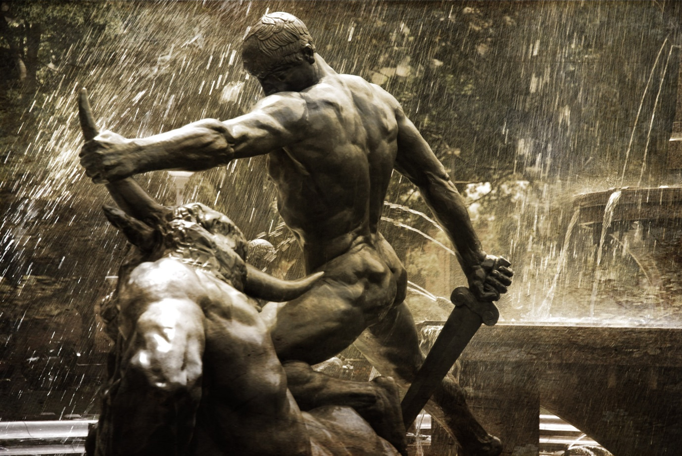

# Game Labs II - Group 7 members

Hadewij Homan - Producer

Thomas Vos – Planner

Niek Schlosser – Art Lead

Dees Veen – Dev Lead

Nathaly Neleman – Level Designer

Arne van Ommen – UX Design

Marc Hoogkamp – QA

# Table of contents

• Story/Concept

• Level Progression and design

• Target Audience/Platform

• Art Style

• Technical concept

• Characters

• Enemies/Obstacles

• Key items and Pick-Ups

• UI

• Resource budget and modular assets

# Story / Concept

Our game revolves around the Greek mythical hero Theseus. A man who is known for slaying the Minotaur.

Theseus is an 18-year old man who lived his whole life in Athene and has been training his whole life on the Greek training grounds. On the day he turned eighteen he gets a vision from his father who remained unknown until that moment. In his vision it becomes clear that Poseidon is his father and has a quest for Theseus.

Poseidon requests that Theseus slays the Minotaur that has been held captive in the labyrinth for many years. He tells Theseus that there is a sword hidden for him under an enormous boulder that resides in the city of Athene and that It takes a lot of strength for a man to lift such a boulder. At the end of his vision, Poseidon tells him that he will grant him eternal glory if he succeeds.

Once Theseus retrieved the sword he goes on his way towards the labyrinth to for fill his quest. He has to cross open roads and fields where bandits wait for travellers.

**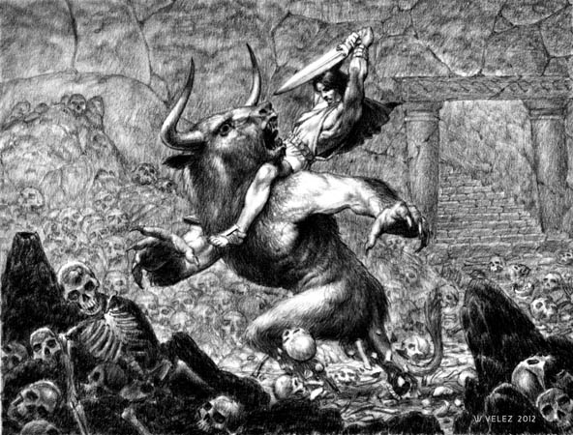**When Theseus finally reaches the labyrinth he has to find his way through this treacherous maze to complete his quest. He finds out the labyrinth isn’t what it looks like from the outside. The walls are moving which makes it a dangerous journey, he also finds out that he isn’t alone. He has to fight his way through the maze to reach the centre. Once he reaches the centre of the labyrinth he comes face to face with a monstrous creature, which is part bull, part man. He realizes he has to kill this creature with only a sword. Here Is where the real fighting begins…..

Level Progression

## Level Progression and design

## Level 1 - City of Athene

## The player will roam through a part of Athene, suddenly he will receive a vision from his father Poseidon. Telling him to kill the Minotaur from the labyrinth, in order to achieve this Theseus has to retrieve a broadsword from under a boulder. He will have to lift this boulder with his strength to receive the sword. Once he retrieves his sword he will make his way to the front gate of the city.

**Level 2 - Open road and fields**

## When Theseus has retrieved the weapon and his quest is clear he travels to the labyrinth, in order to get there he has to travel through open fields where danger awaits. Bandits are watching the roads and can lure you into a trap for your loot.

## Level 3 - Labyrinth

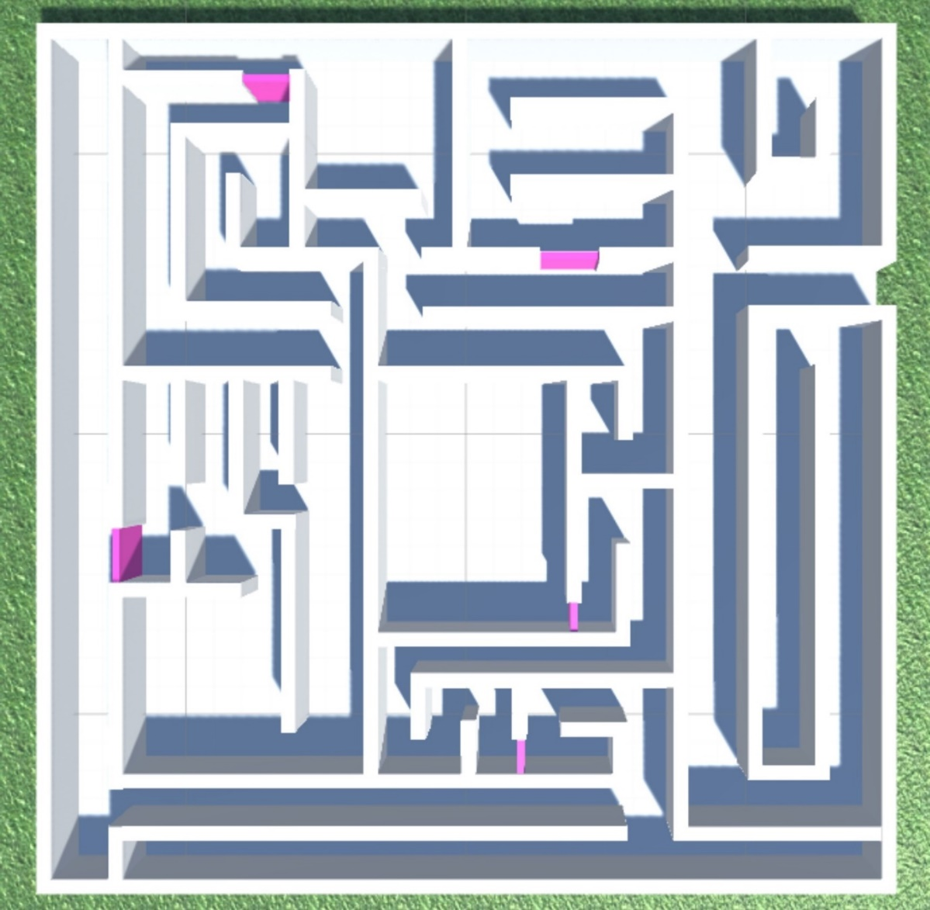When you have reached the labyrinth you can enter immediately. When you have entered the labyrinth you will need to find a way through the treacherous maze that will move over time. You will also have to defend yourself against survivors who still reside inside the labyrinth after all these years. Your goal is to reach the centre of the labyrinth where the Minotaur await. Your quest is to defeat the Minotaur.

**Level design**

As for level design we choose for a more greek feeling than the original story which takes place on Creta, we choose to recreate a part of The city of Athene.

We think this will have a positive impact on our gameplay and immersion as the original story is quite vague and this puts you right in the feeling.

Another choice we came across for level design is having more open space than the city initially had so you have more room to battle and explore our game.

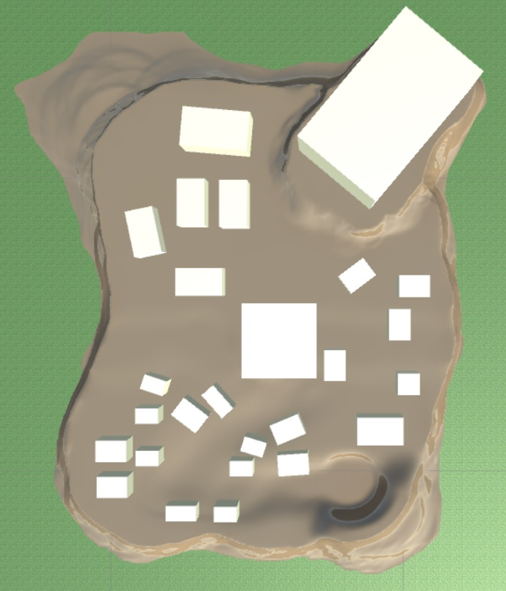

City of Athene

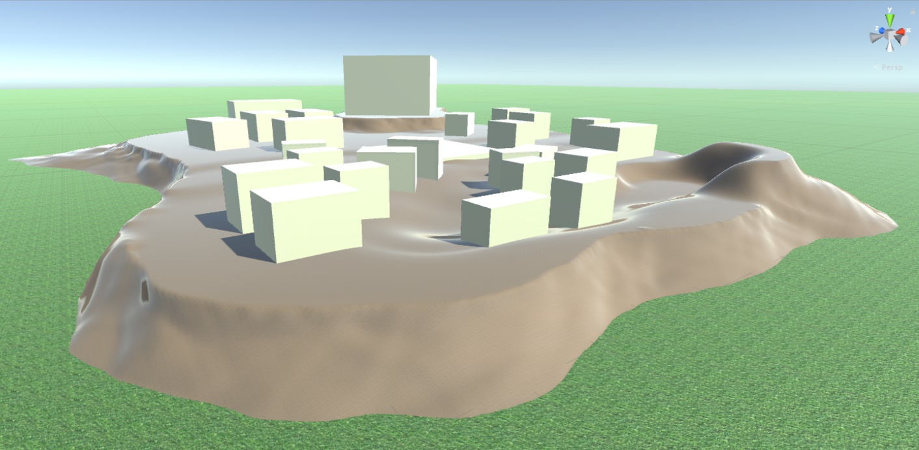

**Target Audience and Platform**

# Target audience: This game is meant for anyone who has any interest in greek mythology. We do restrict the game to a minimum age of 12 years, since there will be a certain amount of violence. We still need to consider if it won’t be a game for 16 years and older when it comes to blood and gore but this is still a work in progress. Beside this, it still is a action game so the player does need to have a interest for this genre.

# Platform: The game will be for PC.

# Art Style

We choose to work with a semi realistic style with PBR. The assets will not be overly detailed, but will have a set degree of details that’s needed to bring out the beauty of ancient Greece and to emphasize with our story.

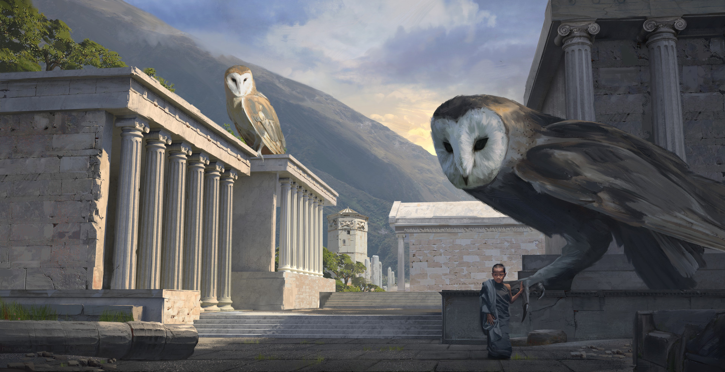

**Reference boards environment and architecture.**

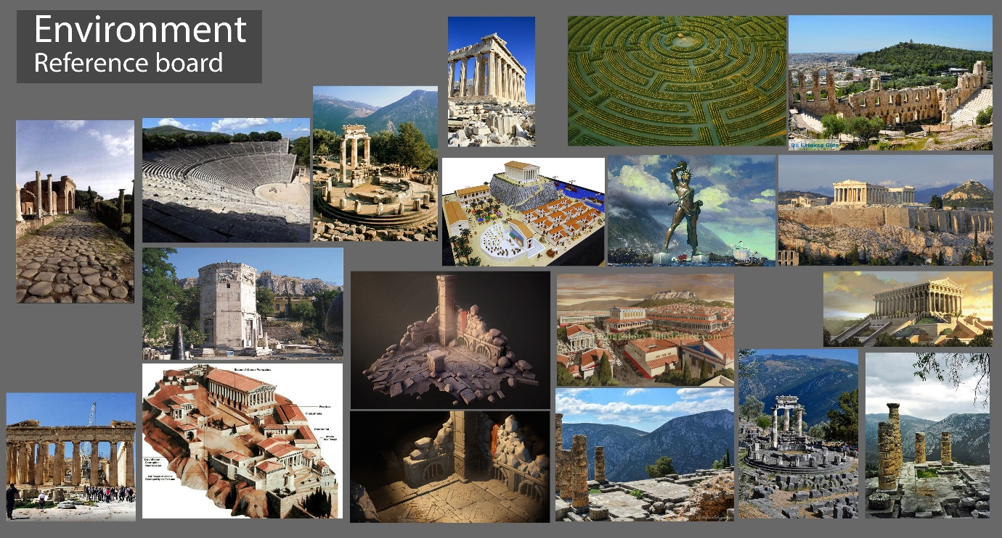

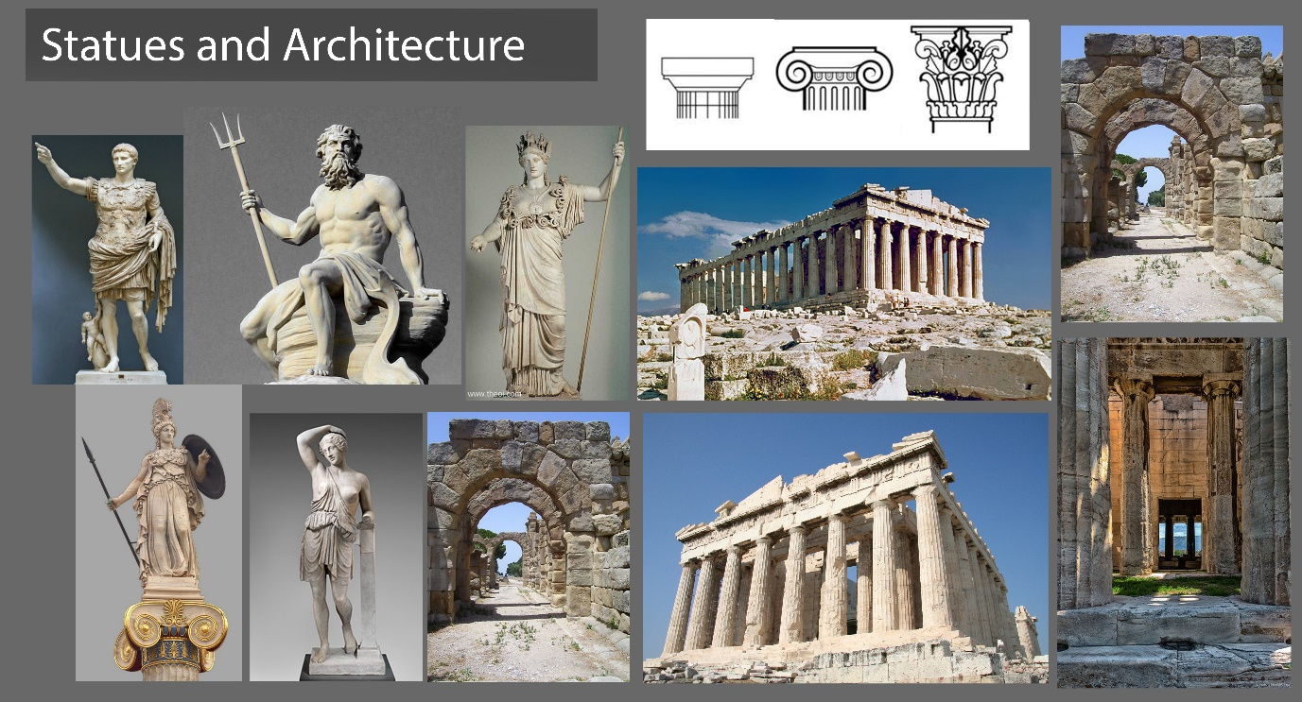

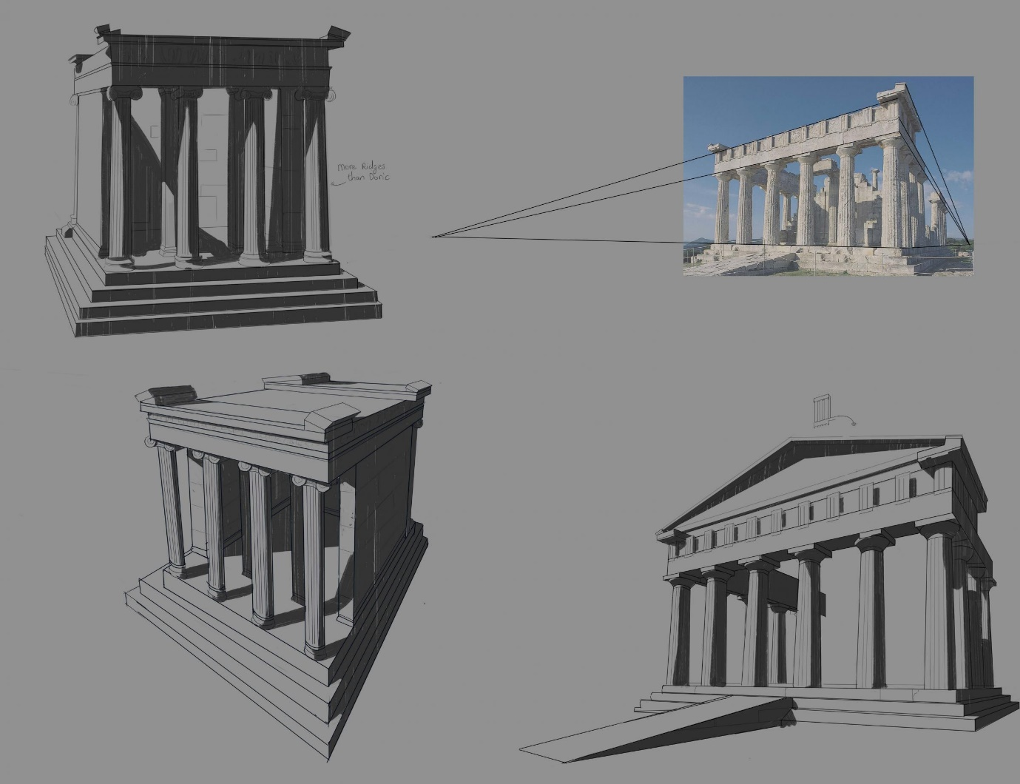

**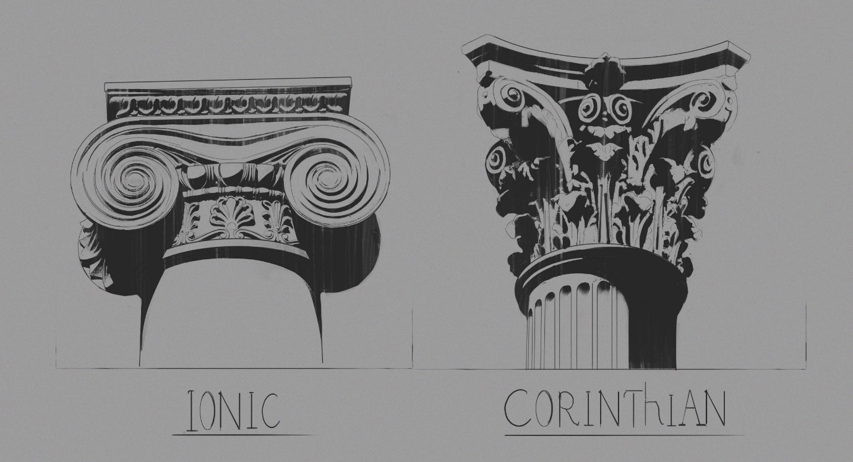**

# Technical concept

## Camera

* The player will move forward to the point where you look at.
* The head can be rotated by mouse
* The player will have a lock on the vertical point of view.
* Medium camera speed
* The camera will be from a first person view, you will only see the arms.

## Controls General

The player will be able to move with **WASD buttons**.

We are using multiple mechanics.

* Crouch
* Jump
* Run

You can crouch by pressing **ctrl** or **c**

Jumping will be enabled by pressing **space bar**

When holding **shift** and **w** you will be able to run.

You can have interaction with objects for example picking up a different weapon by pressing **E**.

To enable your stats screen you can press **TAB**.

**Combat Controls:**

Press **left mouse** button(**fire 1**) for a normal sword attack

Press **right mouse** button(**fire 2**) for a heavy attack (There will be a visible cooldown on your heavy attack)

Press **space bar** and **mouse button 1**(f**ire1**) simultaneously for a jump attack, you will stab with your sword.

Press **ctrl/c** and **mouse button 1**(**fire 1**) simultaneously for a crouch attack.

## RPG element:

To ensure the RPG element in the game we will add a level up system. You can earn XP by killing enemies. You can earn more XP by killing certain enemies.

After a certain amount of experience point you will level up. With each level you will get more HP and damage, you can view this in your stats screen. Those extra’s will be added on top of your basic stats.

The amount of XP needed depends on your current level. For example if you are level 5 you will need more XP to level up than when you are level 0.

Your XP will be monitored in the experience bar that will be at the bottom of your screen.

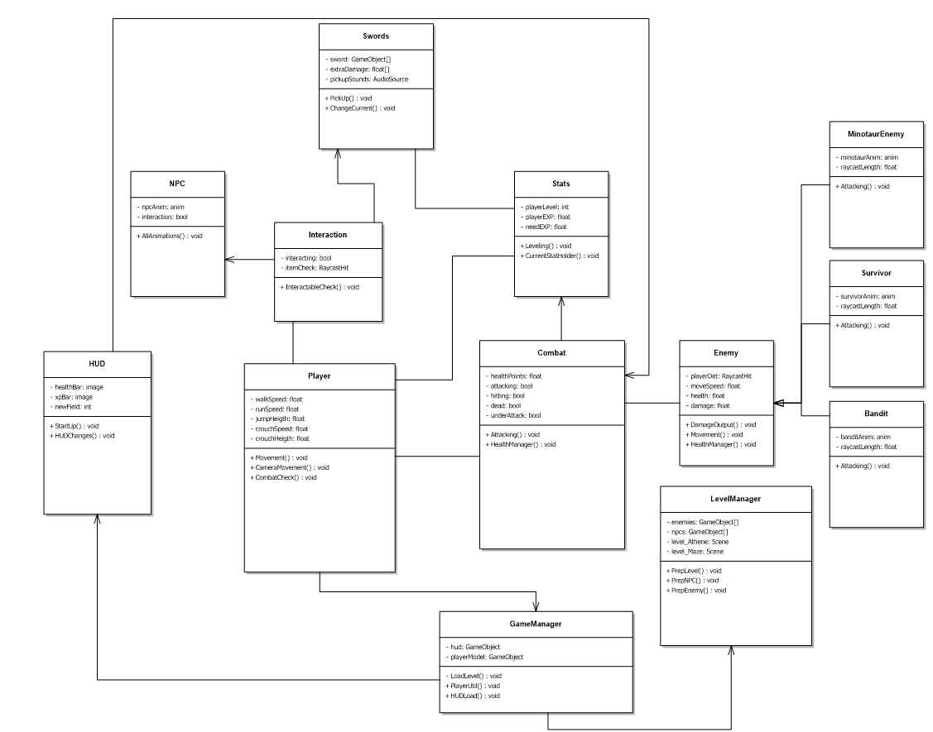**UML:**

# Characters

**Theseus:**

Our main character is Theseus. He will be played from a first person aspect. This means you will only see his arms. Theseus will be wearing Greek bracers to give the player a Greek feeling. Overall he is a muscular man and wields a Greek broadsword to fight of enemies and slay the minotaur.

**Poseidon:**

Poseidon will give you your quest, you won’t see him physically but you will only hear his voice in your vision.

**Npc’s:**

Our Npc’s will be friendly citizens and Greek soldiers. The citizens will wear classic Greek clothes and the Greek soldiers will wear armor. They will be in Athene and on the road towards the labyrinth. We choose to add Npc’s to give the player the feeling that they are playing in an energetic world.

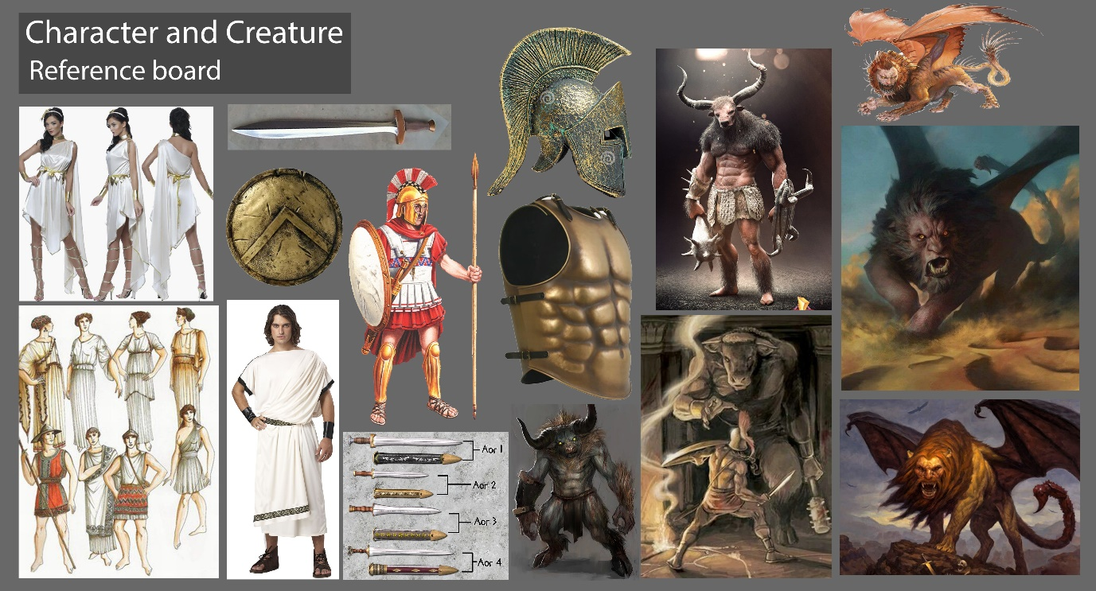

Enemies/Obstacles

**Minotaur(Boss)**

Our main enemy will be the mythical Minotaur who resides in the centre of the labyrinth. The Minotaur is a powerful half bull, half man like creature that will feast on the flesh of those who are send to him. He wields a great axe to secure his meal and will do anything to kill you.

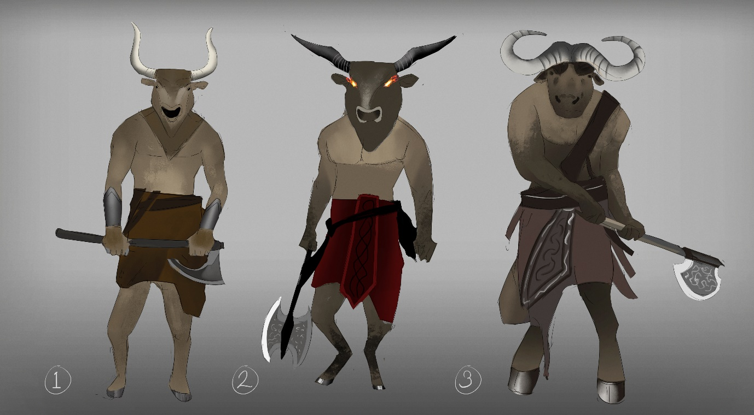

**Bandits:**

Bandits will be roaming over the roads towards the labyrinth. Their main goal is to kill you for your loot.

They will be wearing clothing and armor from civilians and Greek soldiers who they have killed and looted earlier.

**Survivors of the Labyrinth:**

These are people that have survived for many years in the labyrinth. During these years they have transformed into what we call the survivors. They will do anything for food and will try to kill you when you enter the labyrinth. They will have the appearance of feral people.

**The Labyrinth:**

The labyrinth is a treacherous maze where the walls move to add more dimension and variation to the level.

Key items and Pick-Ups

**Broadsword:**

# Our main weapon is a broadsword that you will need to pick up at the beginning of the game after you receive your quest from Poseidon. We decided to go for a classic Greek broadsword.

# C:\Users\hadew\AppData\Local\Microsoft\Windows\INetCacheContent.Word\^294125BD6EEDDEE1605BC476D5A9028A6577FF27DE3E4E5DEA^pimgpsh_mobile_save_distr.jpg

# Weapons:

# As pick-ups we decided to go for extra weapons. Throughout the game you can find different melee weapons like swords and axes. They will have different tears that will go up the further you get in the game and will give you extra damage and health stats.

# UI

## Main Menu

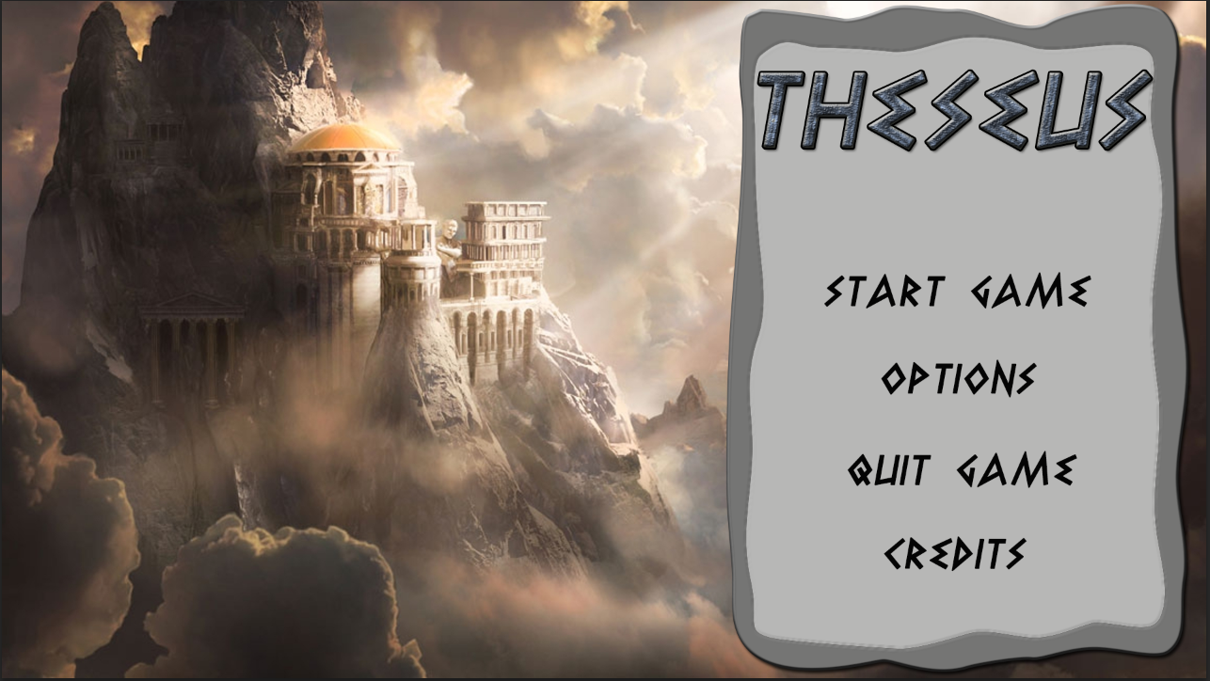

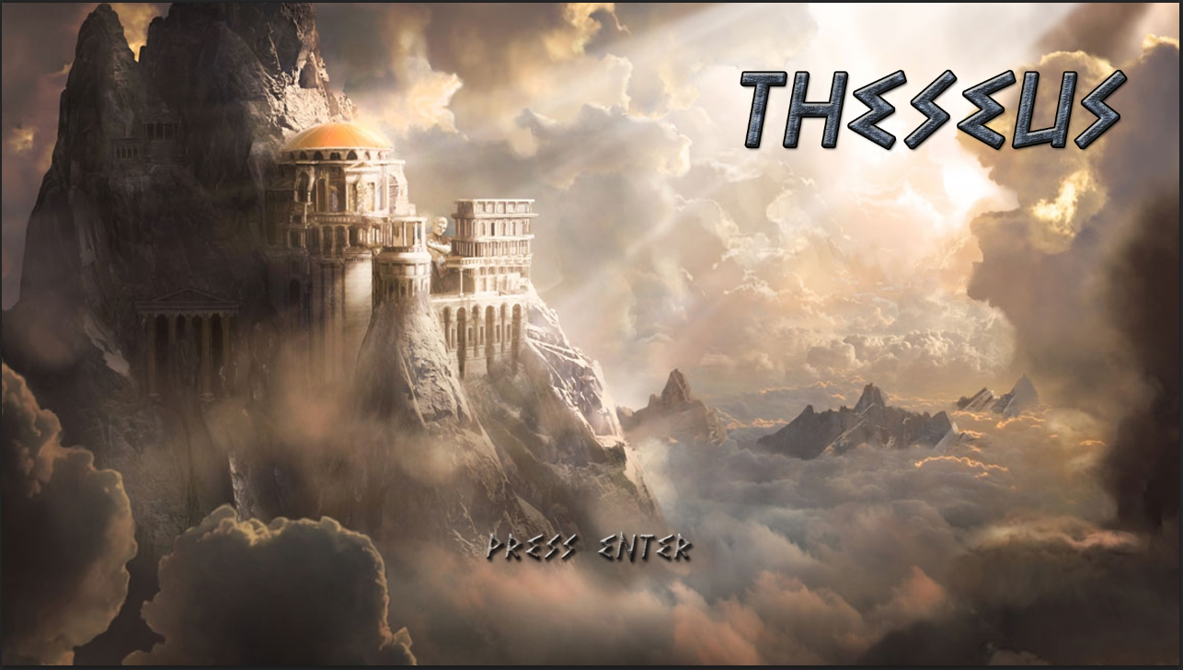

The main menu will consist of a concept art that will do as background. Since it is a vertical slice we have made two examples. The first one will have a button panel for starting and closing the game etc., the second one will have a press enter sign that will automatically start the game.

## In game HUD

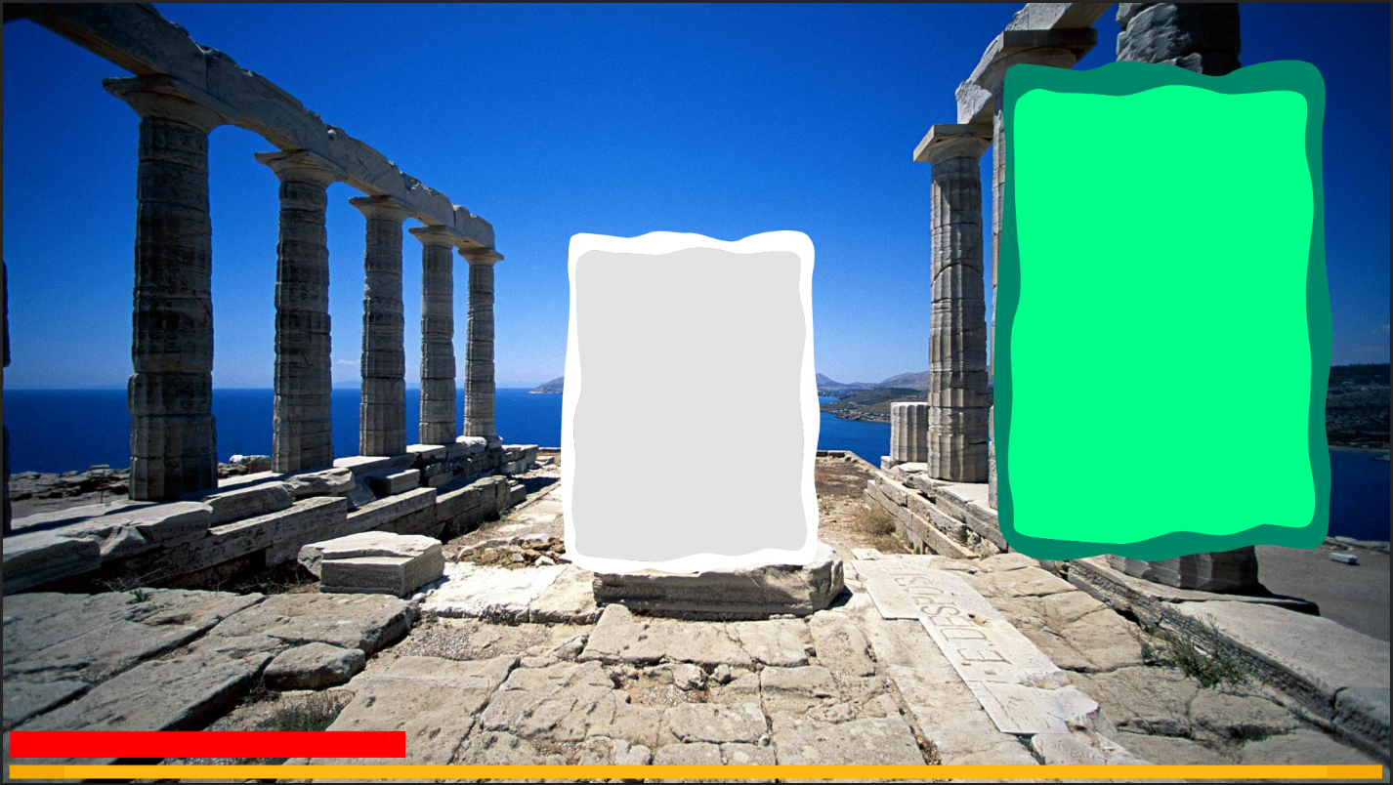

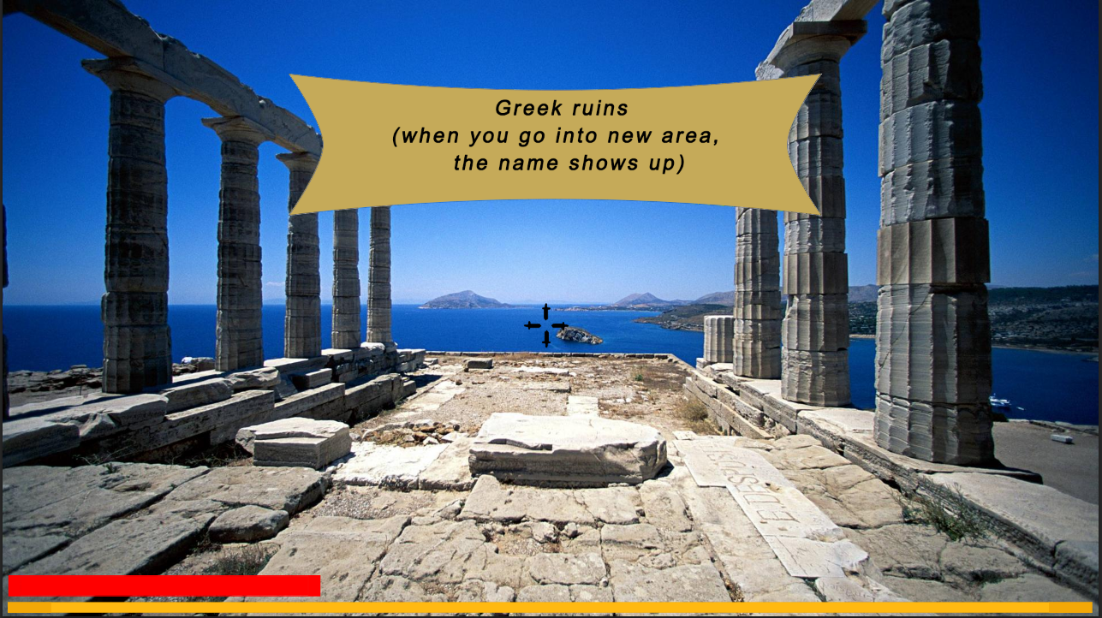

Overall in game position of the HUD. This is not the final look of the HUD only the position!

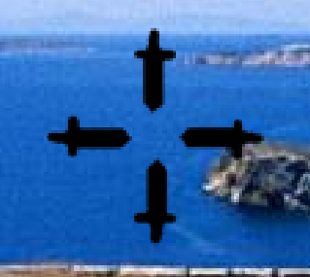

The crosshair will stay in the middle of the screen and will exist out of four little swords to refer to the greek time.



Our health bar and experience bar will be placed at the bottom of the screen. When you are out of combat the bars will fade out, when you are in combat they will re-appear.

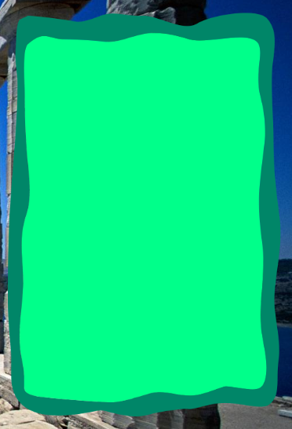Our stats panel will appear at the right side top corner of your screen. You can open this manually to visit your stats and extra information. Here you can see your health, total damage, strength and your basic stats.

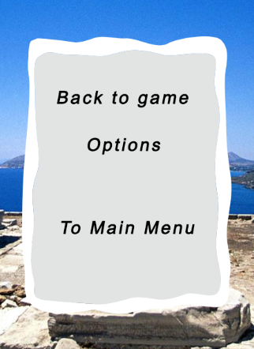Our in game menu can be opened by pressing Esc.

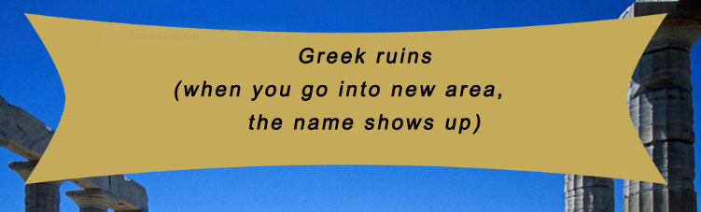

When you enter a new area a banner will appear into your screen to inform you where you are.

Resource Budget

## Prop polycount

**Characters:** max 40k tries

**Environmental:** As low as possible

**Props:** As low as possible depending on the model

## Texture resolution:

**Environment:** 512x512 and 1024x1024

**Characters:** The characters for example bandits will have a a texture resolution of maximum 2048x2048. The main character will get a 4k texture resolution, this because you will only see the arms and we want to put as much detail in them as we can.

## Environment detail:

We try to manage a polycount as low as we can depending on the model. But we try to add as much detail as possible without raising the polycount to much.

|  |  |  |
| --- | --- | --- |
| **Assets** | **Polycount** | **Texture Resolution** |
| **Characters** | Max 40k tries. | 2k resolution, main character 4k resolution |
| **Environmental** | As low as possible, depending on the model. | 512x512 and 1024x1024 |
| **Props** | As low as possible, depending on the model. | 512x512 and 1024x1024 |

**Modular assets:**

For modular assets we decided to use one or two models for example houses, and give those several textures to avoid repetitiveness.

We will also do that for the walls inside the Labyrinth and other city props.